Scientist, Inventors and Innovators
As part of the 3rd/4th Grades Quarter 1 ALP, we will be conducting a Mini-Research project by reading and reporting on a BIOGRAPHY of a Scientist, Inventor or Innovator.

Reading materials and specific steps, due dates and guidelines will be provided.
STEP 1: Write your TOP 3 choices, in order, beginning with the FIRST CHOICE.
DUE DATE: Tuesday, September 13, 2016
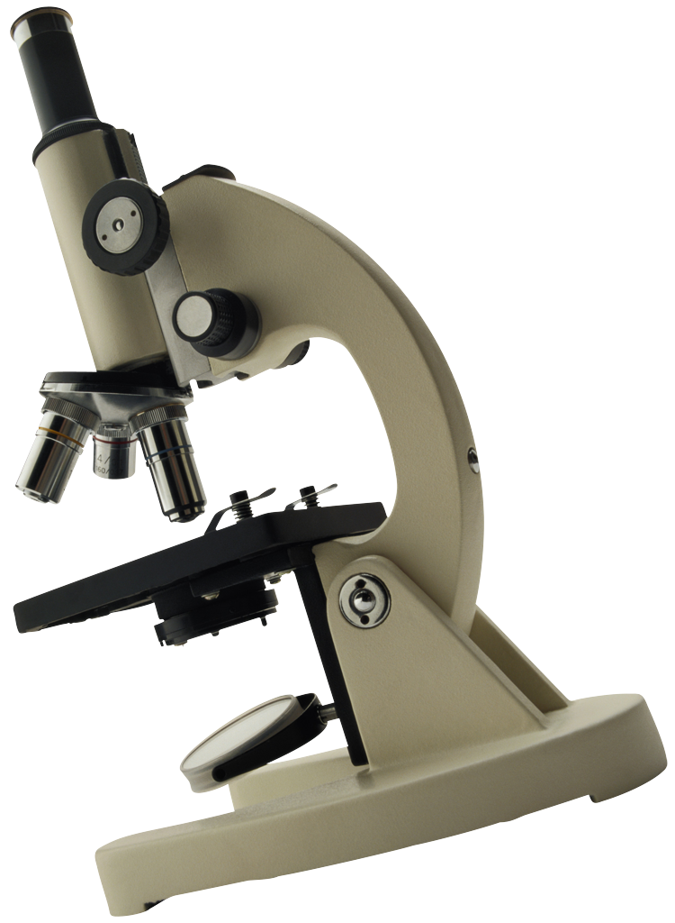
1: _________________________________________________________________________
2: _________________________________________________________________________
3: _________________________________________________________________________

- Luis Alvarez ~ Atomic bomb developer
- Alexander Graham Bell ~ Inventor of the telephone
- Elizabeth Blackwell ~ First female in the US to graduate from medical school
- Barnum Brown ~ Discovered Tyrannosaurus Rex
- Julia Child ~ Adapted French cuisine for an American audience
- Rachel Carson ~ Biologist and Environmental Activist
- Madame Marie Curie ~ Pioneer in the study of radiation
- Leonardo DaVinci ~ Artistic genius of the Renaissance
- Walt Disney ~ Innovative animator and founder of theme parks
- Charles Drew ~ Physician who developed ways to process and store blood
- Amelia Earhart ~ First woman to fly solo across the Atlantic Ocean
- George Eastman ~ Mass-produced his Kodak camera invention
- Albert Einstein ~ Theory of Relativity
- Ruth Elder ~ Pilot known as “Miss America of Aviation”
- Paul Erdo ~ Mathematician
- Henry Ford ~ Created the assembly-line production for the automobile
- Galileo Galilei ~ The Father of Modern Science; astronomer
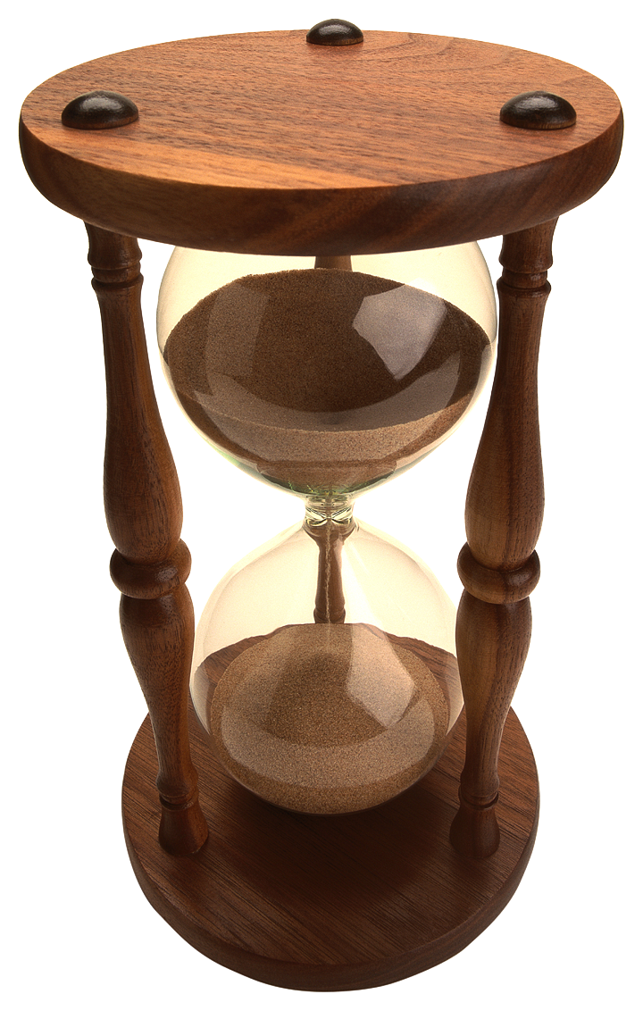

- Bill Gates ~ Founder of Microsoft
- John Glenn ~ First US astronaut to orbit Earth
- Jane Goodall ~ Anthropologist who worked with primates
- Jim Henson ~ Puppeteer and inventor of the Muppets
- Milton Hershey ~ Developed a formula for mass produced milk chocolate
- Steve Job & Steve Wozniak ~ Founders of Apple Computers
- Mary Leakey ~ Paleoanthropologist who discovered skull fossils
- George Lucas ~ Film producer and special effects pioneer
- Lise Meitner ~ Nuclear fission
- Shigeru Miyamoto ~ Nintendo game designer
- Sir Isaac Newton ~ Laws of Gravity
- Katherine Stinson ~ Aviator known for stunt and exhibition flying
- Louis Pasteur ~ Food process known as pasteurization
- John Wesley Powell ~ Geologist to first explore the Grand Canyon
- Carl Sagan ~ Astronomer of the people
- Sebastian Thrun ~ Google glass and robotics innovator
- Daniel Hale Williams ~ Surgeon who opened hearts and minds
- Frank Lloyd Wright ~ Modern architect
- Orville and Wilbur Wright ~ Pioneers of aviation

